Google Inc. Financial Statements Analysis
Name
Southern New Hampshire University

Google Inc. Financial Statements Analysis
Introduction
Financial statements are usually crucial operational tools for business organizations and entities. The cash flow statements, income statements as well as the balance sheet are examples of the integral tools of operations in the company’s financial statements. Various stakeholders such as creditors, managers, investors, as well as executives utilize such tools to examine the organization’s previous fiscal standings and performed at different periods. This paper provides an overview of Google Company by discussing its history, products, and competitors. Additionally, the paper will discuss Google Inc.’s recent financial performance by focusing on the consolidated income and cash flow statements as well as the organization's acquisitions. Finally, the paper will analyze Google's current financial health through its financial ratio analysis.
Company Overview
Google Company is a multinational technology firm which produces as well as trades on the internet related services and products. Some of Google Inc.’s services include cloud computing, search, and advertising (Google Inc., 2017). Google Company was established in 1998 September by Stanford University’s Ph.D. students, Sergey Brin, and Larry Page. The company's headquarters is based in California, The United States of America. Google Company over the past few decades has expanded its products and service portfolio resulting from the establishment of different products and services beyond its usual search engine (Amy, 2013).
Products and Services Offered by Google Company
Google Inc. Provides products such as Ad Sense, a system that allows websites and blogs which are components of Google network to deliver various advertisements; Ad Words, a program which and auction-based system ;Double Click Advertisement Exchange, the marketing platform for trading space and display; Google Display, the display network for advertising platform; Google Local, a program that offers the local information; Google Chrome OS, the open search engine operating system(Google Inc.,2018); YouTube; a social network platform which provides interactive , videos as well as other advertisement formats; Google+, a platform for sharing various information and items online; Android, a the organization’s platform for the mobile software; Google Play, the company’s cloud-based digital applications and entertainment destination; Google Television; platform through which consumers use internet and television on a single screen; Google Drive, a platform for the users to keep, collaborate, share and create their things; Google Applications, the cloud computing suitable for collaboration tools and messages; Google Wallet, the virtual wallet through which the users store their numerous payments; Google Earth Enterprise, a system that provides solution for data and imagery visualization; and Google Appliance Search, a program that provides the search technology for utilization within the organizations. Additionally, Google Incorporated (Amy, 2013). The Company also provides mobile wireless electronics as well as other related services and commodities.
Google Inc.’s Organizational Context
Google Inc.’s organizational structure is cross-functional, that is technically matrix organizational structure with substantive flatness degree. Hence Google’s organizational structure has three major features: flatness, product –based description, and function-based definition. The company utilizes function as the primary technique of grouping workers. For instance, the organization has a product management team, design, and engineering team.
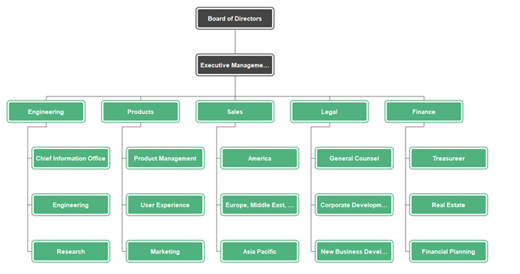

Google Inc’s Recent Financial Performance
Consolidated Income Statements of Google Inc. for three years (2016-2018)
The income statements of Google Company represent the information on the organization’s business operations over a given period. Additionally, the company’s income statements often communicate the amount of revenue the organization generated over a certain fiscal year as well as the cost incurred during revenue creation. This section will analyze year- to year changes Google Inc’s revenue, net loss or profit, operation income, and earnings before depreciation, taxes, and interests
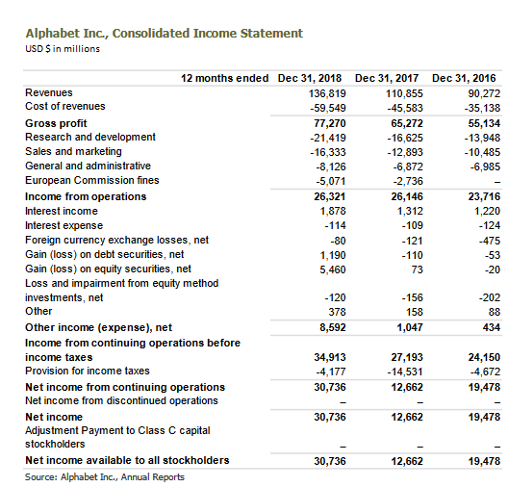
Figure 2: Google Company’s consolidated income Statements (Google Inc., 2018)
Revenue
Revenue refers to the amount of income, including the amount of tax collected from the clients, of the income from performance satisfaction. The records in figure 1 indicate that Alphabet (Google). From 2016 to 2017, Google Company’s revenue increased by $10, 138 million (18.39%) and by $11, 898 million or 18.23% from 2017 to 2018. Google Inc.'s increase in revenue from the year-to-year (2016 to 2017 and 2017 to 2018) was basically due to a small increase in the costs or expenses associated with the generation of the company's revenue from sources such as advertising.The costs incurred by the company increased from 2016 to 2017 by $10, 445 million or 29.73% ( from $35, 138 million to $45, 583 million) and from 2017 to 2018 by $13,966 million or 30.64%( from $45,583 million to $59,549 million).Additionally, Google Inc.'s gross profit increased from 2016 to 2017 by $ 10, 138 million and from 2017 to 2018 by $ 10, 889 million
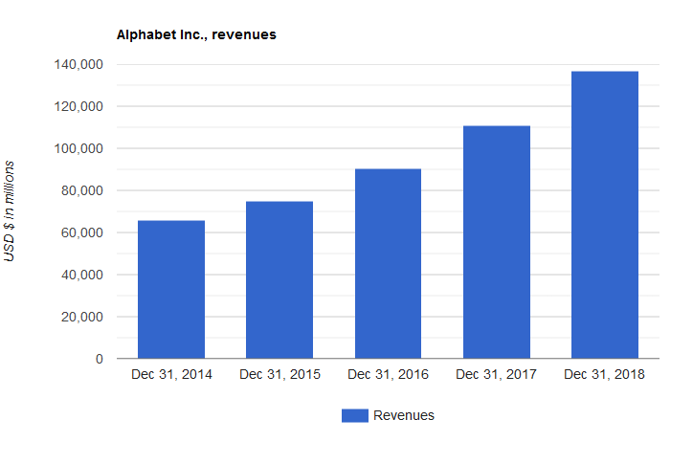

Operation Income
The net income of Google Inc. usually results from the deduction all the cost associated with the revenue generation or operations from the company’s generated revenue. The operating income of Google Inc. From 2016 to 2017 by $ 2, 430 million or 10.25% (from $23, 716 million to $26, 146 million) and from 2017 to 2018 by $175 million or 0.67 %( from $ 26, 146 million to $26, 321 million).Also, the cost associated with the revenue generation such as research and development; marketing and sales; European commission fees; and General and administration. Additionally, Google Inc.’s net income available to their shareholders declined from 2016 to 2017 by $ 6,815 million or 35%( from $ 19, 478 to $ 12, 662 million) but increased from 2017 to 2018 by $18, 074 million or 142.74. Net income declined from 2016 to 2017 because the cost associated with the creation of income such as interest expenses, debt securities, income taxes was very high compared to interest income gross gains, and investment as shown in figure 1.

Earnings before depreciation, taxes, and interests
This refers to the amount of loss or income from the continuing Google's business activities, income the deduct amount of income from equity investments before depreciation, income taxes, and interests adjustments (Google Inc., 2015). Google Inc.’s earnings before depreciation, taxes, and interests increased from 24, 150 million dollars to 27, 193 million USD dollars (From 2016 – 2017) and from $ 27, 193 million to $ 34, 913 million (from 2017 – 2018).
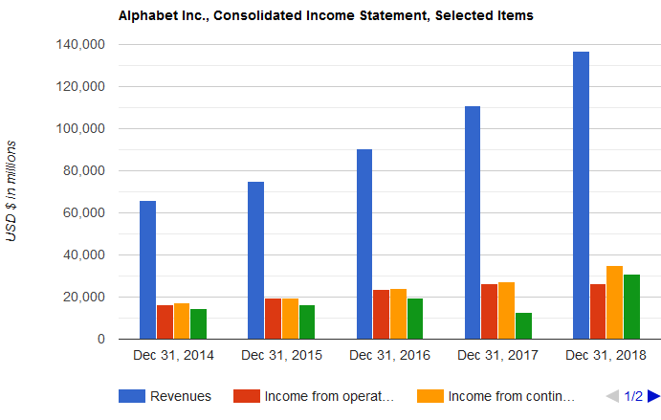
Figure 2: Google Inc.’s consolidated Income statements
Google Company’s Integrated Cash flow Statement

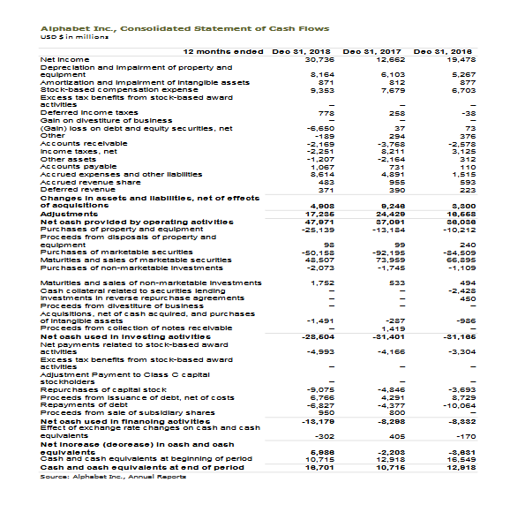Figure 3: Consolidated Cash flow statement for Google Inc. (Google Inc., 2018).
Google Company’s Cash from statements offers information concerning the organization’s cash payments and cash receipts during a particular accounting period, indicating how various cash flows connect the firm’s ending balance to the starting cash balance indicated on the organization financial position statement. The cash flow statements usually consist of cash from financing, cash from investing activities, and cash from operating business activities.
Cash from Operating Business Activities
Refers to the amount of outflow (cash flow) from Google Company’s operating business activities, excluding the discounted organization’s business operations. Cash from the operating business activities includes the changes in value that are not described as financing or investing in business activities. Figure 3 indicates Google Company’s cash from operating business activities increased from $ 36, 036 million to 37, 091 million US dollars (from 2016 – 2017) and from $ 37, 091 million to 47, 971 million dollars (2017-2018).
Cash from investing activities
The amount of outflow (cash flow) from Google Inc.'s investing business activities, excluding the company’s discounted business operations. Cash from the investing business activities includes collecting and making loans as well as disposing and acquiring debt or equity property and instruments, equipment, and plant as well as the organization’s other productive assets (Amy, 2013). Figure 3 shows that Google Company’s net cash from the investing business activities decreased from -$31, 165 million in the year 2016 to -$ 31, 401 million in 2017. However, it increased from -$ 31, 401 million in 2017 to -$28, 504 million in 2018.
Cash from financing activities
Cash from the financing acuities usually refers to the amount of outflow (cash flow) from Google Inc's financing business activities, excluding the organization’s discounted business operations. Cash from the financing activities often includes obtaining various resources from the company’s shareholders and offering the owners with the return of as well as return on investment; borrowing funds as well as settling obligations, or repaying the debts; and repaying the different resources acquired from the organization’s creditors on long-term basis (Google Inc., 2017). Figure 3 above shows that Google Company’s cash from financing business activities increased from -$ 8, 332 million in 2016 to -$8, 298 million in the year 2017. However, it declined from -$ 8, 298 million in 2017 to -$ 13,179 million in 2018.
Google Inc.’s Underlying Financial Performance
Over a few years ago, Google Inc. acquired Motorola which brought Google Company the mobile segment. Google Inc. is spending a huge amount of resources to expand its large Googolplex. Mobile (Amy, 2013). Google Company expects to acquire Motorola production patents to build mobile devices to enable the organization to compete with large players like Apple and Samsung, it was ready to develop mobiles features using its Android. Additionally, the organization moves with Google Fiber into the internet market to assist obtain advertisements.
Google Inc.’s Current Financial Health
Google Inc. is usually the leader among the major organizations in the technology industry. Google Inc. is often listed with the Federal Govern Contractors, Marketing Services and Programs, Internet Search Engines, and Website Hosting. The organization's three competitors include MSN, Yahoo Inc., and AOL (Google Inc., 2015). Ratio analysis of the three years (2016, 2017 and 2018) reveal the profitability and efficiency of the organization within the industry. Google Inc.’s generated a revenue of $ 55.134 million was generated in 2016, $65,272 in 2017, and 77,270 in 2018. Google Inc.’s current financial health can be evaluated through the assessment of three important factors: its profitability, leverage, and liquidity.

Google Inc.’s Cash and Cash Equivalent
Google Inc.’s cash increased from 2016 to 2017 by $15.3 billion or 17.73 %( from $86.3 billion to $101.9 billion) and from 2017 to 2018 by $ 7.2 billion or 7 %( from $101.9 billion to $109.1 billion)
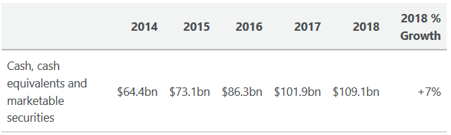
Figure 5: Google Inc.’s Cash and Cash Equivalent
Google Inc.’s Debt, Debt to Equity Ratio, and Shareholder’s Equity
Item | 2018 | 2017 | 2016
Long term debt | $4.01 billion | $3.97 billion | $3.94 billion
Shareholder’s Equity | $177.63 billion | $152.50 billion | $139.04 billion
Debt to Equity ratio | 0.02 | 0.03 | 0.03
The Google Company’s shareholders equity increased from 2016 to 2017 by $13.46 billion or 34.48% (from $152.50 billion to $139.04 billion) and from 2017 to 2018 by $25.13 or 16.48 %( from $ 177.63 billion to $152.50 billion). This indicates that the amount of money invested in the organization increases the year-to-year. The Company’s total debt increased from 2016 to 2017 by $0.03 billion or 0.76 %( from $3.94 billion to $ 3.97 billion) and from 2017 to 2018 by $ 0.64 billion or 16.12 %(( from $3.97 billion to $4.01 billion).
Debt to Equity ratio is a financial metric used to measure the total debt of an organization relative its asset value, it is usually used to determine the extent to which an organization is obtaining long term debts as a way of leveraging their assets. Is calculated by diving total liabilities by shareholder’ equity (Amy, 2013). In 2016-2017 period Google Inc.’s debt-equity was 0.03 and decreased from 2017 to 2018 by 0.01 or 33.33 %( from 0.03 to 0.02). Since Google Inc.’s debt to equity ratios are less than one (0.02 and 0.03) the organization’s assets are usually financed through shareholders’ equity.
Google Inc.’s Day Sales Outstanding (DSO)
 | 2018 | 2017 | 2016
DSO | 40.05 days | 41.12 days | 42.01 days
From 2016 to 2017 Google Inc.’s day sales outstanding declined f by 0.8 days (from 42.01 days to 41.12 days) and from 2017 to 2018 by 1.07 days (from 41.12 days to 40.05 days). The day sale outstanding of 40.05 indicates that Google Company had tighter credit regulations in 2018 compared to 2016 in which DSO is 42.01 days and 2017 where day sales outstanding is 41.12 days.
Google Inc.’s Cash and other resources
Google Incorporation’s cash as well as equivalent and marketable securities are $ 86.3 billion in 2016, $101.9 billion in 2017 as well as $109.1 billion in 2018. From 2016 to 2018 Google company’s cash from financing, operation and investing activities increased year-to-year. Additionally, purchase and acquisition of different intangible assets increased also because of Google Inc.’s acquisition of various business entities such as On2, AdMob, Slide Inc., and Widevine Technologies.

Google Inc.’s Financial Value
Google Company’s EPS & EPS diluted
Google Company’s EPS decreased from 2016 to 2017(27.85 billion dollars to 18.00 billion dollars) but increased from 2017 to 2018 by 29% (from 18.00 billion dollars to 43.70 billion dollars)
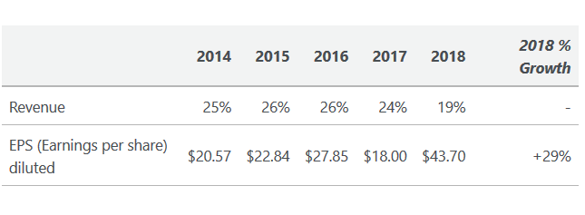
Valuation ratios
Valuation ratios | 2016 | 2017 | 2018
P/E | 78.23 | 43.12 | 51.31
P/B | 12.71 | 8.25 | 7.10
P/S | 15 | 18 | 23
Google’s companies EPS are indicated in the table above shows the company’s high growth rate, as well as significant P/E ratio in the investors, are paying for $78.23 for each one dollar of the earning of Google Company in 2016. Google's Inc.'s P/B in the year 2018 is nearly high compared to others in the market. Indicating that the company’s investors feel that the company is worth more compared to its book value/B illustrates the steady decrease between 2016 to 2018, that is described by the fast increase or growth rate of the organization's book value for every share compared to the price of a share.

References
Amy, S. (2013). Google Incorporation.: Competitive Landscape. Hoovers. Retrieved fromhttp://subscriber.hoovers.com
Google Incorporation (2017). Google Incorporation. SWOT Analysis, 1-20. Retrieved from EBSCOhost.
Google Incorporation. (2017). 2016 Annual Financial Report. Mountain View: Google Incorporation
Google Incorporation. (2018). 2017 Annual Financial Report. Mountain View: Google Incorporation
Google Incorporation. (2015). Company Information: Corporate. Retrieved from http://www.google.com/intl/en/about/corporate/company/

